Music 7–10 (2024): Stage 4 Year 7 – Moving Samples

Unit title: Moving samples
Duration: 10 weeks
Description: In this Unit of Work, students learn how to use a sampler using the Ableton Move device, and create an original piece of music which involves composing and performing. They study at least one model work in detail (Fatboy Slim’s Praise You), and well as a range of other sample-based music from the last 4 decades. They perform this work on the Ableton Move, and may also perform the hook from another song on acoustic instruments. The first four weeks begin with 10-minute musicking Starter Activities, and the subsequent four with sharing “check-ins”. The whole Unit is student-centred, creating opportunities for students to learn about typical sounds and the roles of these sounds in sample-based music (and related music genres).
Meeting the repertoire requirements: Popular music.

Outcomes | Subject-specific information
MU4-PER-01: uses performance skills to demonstrate understanding of the elements of music and communicate musical ideas | Through this unit students will:  - Learn the percussion parts, and optionally other parts, to Fatboy Slim’s Praise You by ear.  - Play Praise You solo and in an ensemble  - Perform and improvise with samples they have created themselves  Students may also:  - Recreate beats and bass lines from songs they are studying or of their own choice  - Perform their own songs live to the class
MU4-LIS-01: uses listening skills to describe music in relation to stylistic, cultural, historical or social contexts and the elements of music | Through this unit students will:  - Identify discrete samples within fully produced songs  - Understand the connections between hit songs and the use of samples  - Rebuild a song by ear  - Learn about how sampling has been used by 3%, a Aboriginal and Torres Strait Islander supergroup  Students may also:  - Work out riffs by ear  - Suggest extra repertoire for the unit
MU4-COM-01: improvises, arranges or composes using the elements of music to create musical ideas | Through this unit students will:  - Learn how sampling works – how to record samples and edit them  - Learn what the typical roles of the bass drum, snare/clap, and hi hat or their sampled equivalents are, and how to utilize them in their own songs  - Compose an original song using these roles and a bass line  - Understand live sequencing/loop based composition/overdubbing  Students may also:  - Learn how to develop one pattern from another  - Add other percussive or pitched layers to their song  - Learn how to use effects and EQ to change samples  - Understand step sequencing/piano roll/matrix editing  - Learn how to combine different patterns into longer songs

Unit information

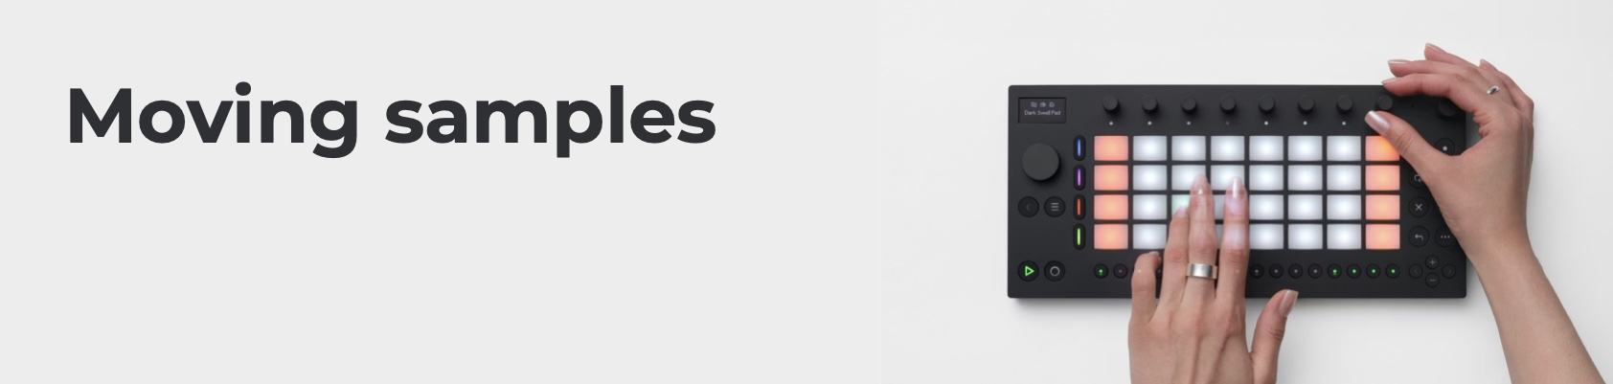
Syllabus reference | Suggested teaching, learning and assessment | Suggested resources
2, 4, 5, 23, 42, 44 | Starter Activity. Sound cards – groups choose cards, work out sounds. Teachers and students take it in turns to build beats out of sound groups.  - Divide into 2 groups.  - Groups choose one card each, work out how to make that sound (some ideas are very abstract).  - Teacher directs students to make sound when they point, establishes beat and some subdivision.  - Divide into 3 groups.  - Each group has a new card (sound), teacher directs again. This time with 3 layers, an obvious 4/4 beat.  - Teacher gives one (confident) student cards, they hand them out to 3 groups, and direct them.  - Can repeat 6 as many times as you like. Don’t forget to shuffle the cards.  - Variation: each group has their own director, but they aim to make a beat together. Can shuffle and repeat and give everyone a go until the 10 mins are up. | Sound cards – see Appendix
9, 45, 20, 22 | Teacher-led sampling activity. Using the crazy sounds students have been making in the starter activity, teacher shows process for recording and editing a sample in the classroom using the Ableton Move.  - Teacher shows process for recording and editing a sample in the classroom using the Ableton Move (adding a template – Gate Kit – to the usual Drum track (track 1); pressing the sample button, then tapping a pad to start and stop recording a sample to that pad. By using the Gate Kit, longer samples can be played by holding the pad.)  - Each sample is recorded with a student making sounds from the cards or found sounds around the room (could be musical instruments, but doesn’t have to be)  - Teacher demonstrates how the samples can be played back (performed) in combination, but doesn’t dwell on this too much | Ableton Move (this lesson can be taught with any hardware or software sampler, but is in this case based around the Move)  The Learn Move website has clear and simple videos.
45, 9, 20, 28, 56 | Student exploration. Students record samples in the classroom, or, if appropriate, in the school/grounds. If there is time, students can share through a higher quality speaker on return to the classroom.

Syllabus reference | Suggested teaching, learning and assessment | Suggested resources
6, 44, 26, 4, 2 | Starter Activity. Sound cards 2 – but this time, in addition to sounds from the sound cards, students choose Boomwhackers or equivalent to make bass lines. Teachers and students make (direct) beats and bass lines in combo, improvised.  - Three students choose “random” boomwhackers (or equivalents)  - 1 student to “trigger” the boomwhackers  - Other students into 3 groups with one soundcard each to choose a sound, and 1 student to lead them.  - Usually best if the sound groups establish a beat first, then bass line group joins in, but teacher doesn’t have to be rigid about it as often grooves will just appear.  - Rotate students on boomwhackers until all class have had a go, or until 10 minutes is up  - Point to the bass instruments collected in the room as sources for bass sounds to sample
45, 43, 44, 8, 28, 27, 24, 42, 22, 56 | Making beats with samples. Teacher shows the very basics of live sequencing with Ableton Move (1-bar loop recording). Student-centred exploration using samples they collected last week, making beats with live recording in Ableton move. | Learn Move video series.
 | Bass (line) station. Teacher has set up a range of bass instruments (e.g. electric bass, trombone, synthesizer, cello) for sampling. Students take it in turns to sample the bass instruments.

Syllabus reference | Suggested teaching, learning and assessment | Suggested resources
20, 21, 22, 31 | Starter Activity. Fatboy Slim Praise You video and associated worksheet. Video: https://youtu.be/ruAi4VBoBSM?si=81wWIqkHZLhZ70F5  Students listen to Praise You by Fatboy Slim and aurally identify the layers sampled in the song. The worksheet (see Appendix) is based on the Ableton Move and has spaces on the pads in which to write the 9 samples used.  Layers that students might identify: The main piano riff; the Bridge Rhodes keyboard riff; Vocal samples, including looped vocal samples to make impossibly long notes; Bass lines, including resampled versions (development of original sampled lines); Guitar riff; Percussion (conga/bongo); Drum kit; Electronic drums. They might also hear people speaking (on the original piano samples) and extra vocal sounds created through reverb and delay effects. | Fatboy Slim guided listening worksheet – see Appendix
22, 28, 42 43, 46, 48, 49, 53 | Copying Fatboy. The teacher loads the specially prepared Ableton Move preset files PraiseInsts.ablpresetbundle and PraiseVox.ablpresetbundle onto the Ableton Moves. This includes the samples Fatboy Slim used to build the song, but not the song data (sequences) themselves. They are to rebuild as much of the song as they can, beginning with the drum beat. | Specially created Ableton files, created by the author.

Syllabus reference | Suggested teaching, learning and assessment | Suggested resources
2, 3, 4, 5, 8, 9, 20, 26, 12, 14 | Starter Activity. Performing Fatboy – iPads are connected to mixers and speakers: student listening and copying the Praise You, to play as much of the full track as possible, one sample each. After 8 minutes, perform whatever students can without the final recording | Specially created Ableton files, created by the author.
42, 43, 44, 45, 46, 48, 49, 53 | Samples and bass. Returning to the samples that students created in weeks 1 and 2, students use their experience with Fatboy’s samples to build a new song or modify one that they had. Implicit teaching – roles of the bass drum, high hat, and snare (or sampled equivalents).
42, 43, 44, 45, 46, 47, 52 | Free exploration. Students who have new ideas for samples, or aren’t happy with their old ones, may record new ones. The teacher provides bass instruments for sampling again. Students are told about Check-ins and the Assessment Task. | Learn Move video series.

Syllabus reference | Suggested teaching, learning and assessment | Suggested resources
47, 25, 28, 52 | Check-in and peer feedback. All students share 10 seconds of a song they are working on. Peers provide advice that is Kind, Helpful, and Specific (Berger, 2003).
42, 44, 45, 46 | Teacher-led tools for fast prototyping. Teacher shows students how patterns can be copied and developed from one another, as well as sequenced, if they have not already worked this out for themselves.
42, 43, 44, 45, 22 | Fast prototyping. Students are to create new samples and/or new patterns from existing samples within a short timeframe. The teacher also shows how samples can be taken from students’ favourite songs – see the video tutorial. The idea is to create lots of original material to share and choose from in future weeks. To be shared in next check-in. | Video tutorial – making samples from your favourite songs.
20, 21, 22, 24, 29, 31, 30, 32, 33, 36 | Sampling in music by Aboriginal and Torres Strait Islander artists (NB this should not be taught as separated content but integrated to the Unit; it is provided in this document as a separate row to make it clear that First Nations music is taught in this unit).  - 3% Coming Home which uses the sample from Jimmy Little Royal Telephone. The significance of Jimmy Little and this song (first number 1 by an Aboriginal artist).  - 3% Our People (clean version) which samples My People by the Presets, and Took The Children Away by Archie Roach. Took the Children Away, the stolen generation, and the use of the sample in the context of this song. | Coming Home  Royal Telephone  OUR PEOPLE (clean version)  My People  Took the Children Away
20, 21, 22, 26, 29, 30, 31, 37, 38 | Extended sample listening. See repertoire list. Teacher to choose which song might be most useful to listen to. Each song in the list has sampled from its partner. Students listen to both until they recognize the sample (some are very easy, some not-so). Students can explore their own sample relationships if the teacher agrees this is useful for their projects. Implicit teaching – roles of the bass drum, high hat, and snare (or sampled equivalents); common patterns in sample-based songs in 4/4 (e.g. bass drum on 1, backbeat for snare or claps, 8th notes for hi hat). | Music from 1970 to the current day that uses samples or musical derivatives (it is possible to replace repertoire with examples from jazz and ‘classical’ music, too).  - Rachel Collier Control  - Dua Lipa Break My Heart  - INXS Need You Tonight  - Childish Gambino Redbone  - Bootsy's Rubber Band I'd Rather Be With You  - Beyoncé Crazy in Love  - The Chi-Lites Are You My Woman? (Tell Me So)  - Black Box – Ride On Time  - Loleatta Holloway – Love Sensation  Optional listening repertoire – see Example repertoire list (above, hyperlinked to Tidal and Spotify), or use www.whosampled.com to find new repertoire.

Syllabus reference | Suggested teaching, learning and assessment | Suggested resources
 | Optional extra (extension activities).
2, 3, 4, 5, 6, 20, 26, 30, 37, 38, 12, 14 | Learn by ear the hook from Beyoncé’s Crazy in Love (sampled from The Chi-Lites Are You My Woman? (Tell Me So)) on classroom instruments (arrangement below). Once the main melody has been learned, teacher teaches (Orff-style) the other pitched and unpitched parts (again, aural learning). | Orff-Keetman Schuwerk instrument arrangement – see appendix.
20, 21, 22, 29, 30, 31, 37, 38 | Australian band The Avalanches 2000 album Since I Left You contains around 3,500 samples. Watch/listen to Frontier Psychiatrist or Since I Left You and then the corresponding section of the Bandstand video to understand what samples are used and how they fit together.  Students draw on music they are already interested in to find a song they love that includes a sample. They must then listen to the song from which the sample was taken, and identify the sample in that recording. See whosampled.com for help. | Link to the album on streaming services.  Bandstand video that provides every sample from the album.
42, 43, 44, 45, 22, 48, 49, 51 | Extension extension: students take the sample that they have located, and try to put it to a drum loop or instrumental loop in their favourite DAW. | Andrew Huang Flipping some Beyoncé samples video

Syllabus reference | Suggested teaching, learning and assessment | Suggested resources
3, 4, 5, 20, 25, 28, 52, 53 | In-class party. Teacher or volunteer student plays all songs through PA for students to hear in highest quality possible. If lighting and dry ice is available, all the better. Dancing is encouraged. If the party does not take the full lesson, students may make last-minute changes to their songs before submitting for assessment at the end of the day. | High quality PA and input for iPads.  Lighting and dry ice.  Refreshments.

Reflection and evaluation (space for teacher to reflect on and evaluate the unit)

Appendix 1 – Syllabus Content Reference Numbers
In the above unit of work, Syllabus Content is given a Reference Number to save space. The numbers are allocated in the order that they are published in the Syllabus. Thus:

Performing
 | Music in practice |  | Music in context
1 | Sing demonstrating melodic and/or harmonic awareness | 12 | Apply stylistic characteristics in performance
2 | Develop vocal and/or instrumental skills individually and in groups | 13 | Understand the purpose of a performance
3 | Perform music in a range of musical styles to communicate musical ideas | 14 | Communicate musical ideas with expression
4 | Perform in an ensemble recognising own role and those of others | 15 | Perform with consideration of composer and audience perspectives
5 | Perform own compositions and those of others | 16 | Perform to audiences in different settings
6 | Improvise on a given musical stimulus to develop musical ideas | 17 | Apply the protocols and responsibilities of working safely and respectfully with others
7 | Perform from musical scores | 18 | Make ethical choices about how music is used in performance, including use of Indigenous Cultural and Intellectual Property (ICIP) protocols
8 | Apply knowledge of musical terminology to rehearse and perform | 19 | Demonstrate understanding of risks and protocols related to information and identity
9 | Experiment with technologies to explore creative possibilities
10 | Demonstrate safe vocal and instrumental practices including correct posture, warm-up and technique
11 | Reflect on own experience of performing to develop performance skills

Listening
 | Music in practice |  | Music in context
20 | Listen to live and recorded music and identify musical features and ideas | 29 | Describe music in relation to a particular time period, culture, genre or style
21 | Listen to and explore a range of repertoire to compare pieces of music | 30 | Make connections between pieces of music
22 | Identify and describe the use of technologies in repertoire | 31 | Describe the stylistic, historical or geographical origins of pieces of music
23 | Interpret a range of musical symbols and follow scores that include notations relevant to the repertoire | 32 | Recognise the purpose of a piece of music
24 | Use appropriate musical terminology to describe and discuss music | 33 | Describe how music of Aboriginal and Torres Strait Islander Peoples can communicate Cultural understanding of Place, Country or Languages
25 | Use written, verbal and multimodal forms to describe how musical ideas are communicated | 34 | Discuss music from the perspectives of composer, performer and audience
26 | Use listening skills and memory to clap, sing or play musical patterns | 35 | Reflect on aesthetic qualities of music in personal responses to repertoire
27 | Transcribe musical patterns using notations relevant to the repertoire | 36 | Discuss how identity can be reflected in music
28 | Use listening skills to reflect on own live or recorded performances and compositions | 37 | Describe how music is adapted or arranged
 |  | 38 | Compare versions of a piece of music to explore different responses and interpretations over time
 |  | 39 | Identify cultural and social protocols in relation to repertoire
 |  | 40 | Identify processes to support ethical choices when engaging with Aboriginal and Torres Strait Islander music
 |  | 41 | Describe the influences on a piece of music, using written form and appropriate music terminology

Composing
 | Music in practice |  | Music in context
42 | Improvise and creatively explore musical ideas in response to a stimulus | 48 | Explore how conventions of different styles and media can be used to create meaning
43 | Improvise and experiment to communicate musical ideas | 49 | Create musical ideas reflective of a genre or style
44 | Experiment with different ways of combining musical ideas | 50 | Compose music inspired and influenced by Australian works, including Aboriginal music within appropriate local contexts, while working with local Community Knowledge Holders where possible
45 | Use a range of sound sources, sound production methods, timbres and digital technologies to improvise, generate, compose, manipulate, arrange, notate and record musical ideas | 51 | Research cultural, historical and social influences to inform own compositions
46 | Document musical ideas using notations appropriate to the style | 52 | Compose with a consideration of performer and audience perspectives
47 | Reflect on and document in writing compositional choices and processes | 53 | Adapt pieces of music or their features for new purposes
 |  | 54 | Apply protocols with respect for Aboriginal and Torres Strait Islander musicians, Communities and Cultural Knowledges, as well as Indigenous Cultural and Intellectual Property (ICIP)
 |  | 55 | Apply the protocols and responsibilities of working safely and respectfully with others
 |  | 56 | Demonstrate understanding of risks and protocols related to information, identity and intellectual property when sharing compositions or other material on public or private forums

Appendix 2 – teaching resources
Crazy in Love classroom arrangement
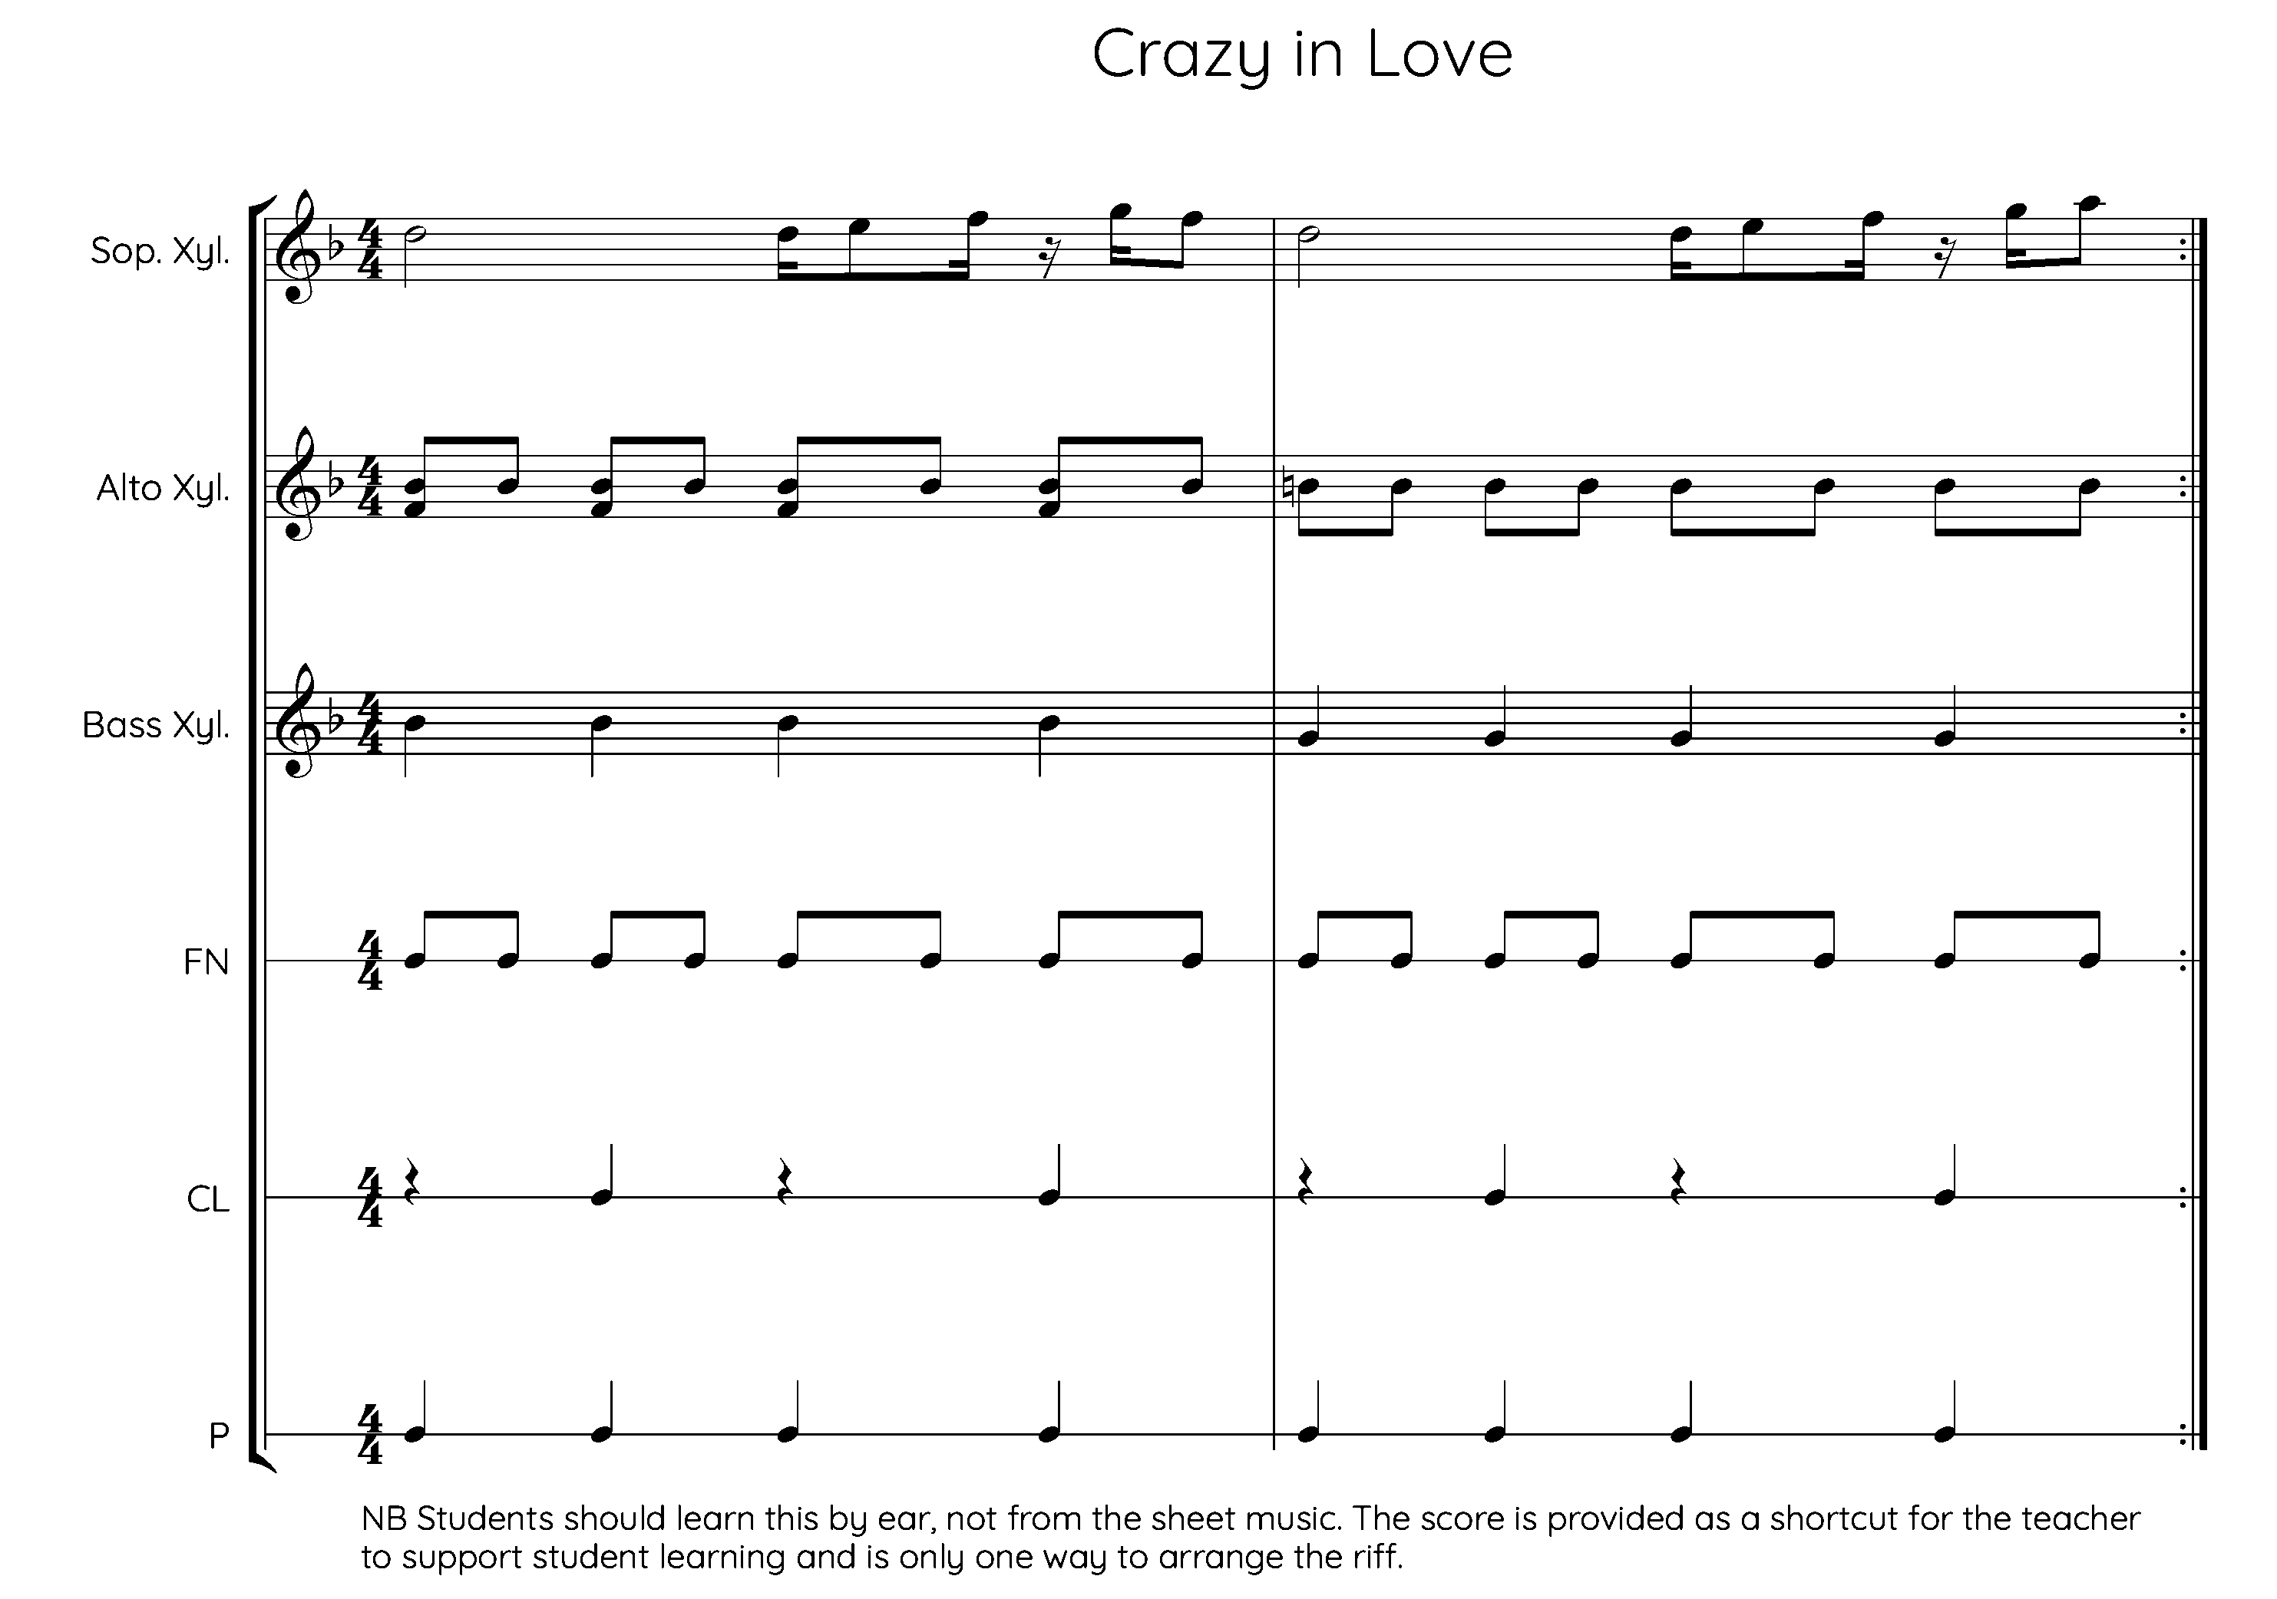

Fatboy Slim Praise You listening sheet

