Schooly McSchool Face
Assessment Task Notification Year 8
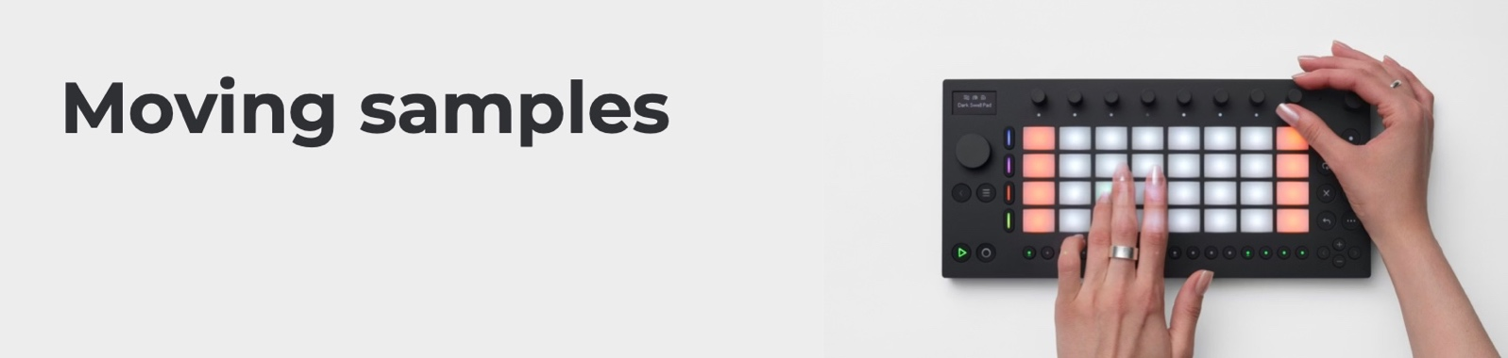
Task Number: 2

Name: | Teacher: Mr Humbledore
Date of Notification: 4th January, 1999 | Date Due: 31st July, 2033
Task Weight: 35% | Total Marks: 35
How to submit task: Export your Ableton Move session via the Ableton Move Manager (move.local), then upload it to Google Classroom

Assessment Policy: This task is a formal assessment task and students need to follow the policy provided in the Assessment Handbook. Assessments must be submitted by the due date and time. Late assessment tasks will be given a mark of zero. Students applying for illness misadventure must hand in the correct documentation in line with the Assessment handbook. It is expected that students experiencing difficulty with an assessment task will see a teacher prior to the task due date.

Outcomes Assessed:

MU4-COM-01: improvises, arranges or composes using the elements of music to create musical ideas
- Student can create a piece of music made entirely with samples that they have captured/created.
- Student can step sequence samples to create rhythms.

MU4-PER-01: uses performance skills to demonstrate understanding of the elements of music and communicate musical ideas
- Student can play samples in time in the style chosen.

MU4-LIS-01: uses listening skills to describe music in relation to stylistic, cultural, historical or social contexts and the elements of music
- Student composition shows evidence of sample skills learned through study of set repertoire (sample-based songs).
- Student composition shows evidence of understanding common contemporary rhythmic styles (e.g. appropriate tempo, four on the floor, back beat, use of high hats, etc.).

Task Description:

What do you need to do this term in music?
Simply make an original song on the Ableton Move! It can be any length and any style at all – the only rule is that you need to have recorded all of the sounds yourself (even if they were made by someone else!).

Things we learned how to do
(You could try these things in your song!)
- Record all kinds of weird and whacky sounds.
- Record sounds that represent typical drum kit roles, such as bass drum, snare, and hi-hat.
- Change the volume or pitch of a sample.
- Add effects to samples, or even reverse them.
- Record samples into patterns.
- Copy patterns to create developing patterns.
- Organise patterns into songs.
- Take inspiration from Fatboy Slim’s song, Praise You, and other songs that use samples.
- Optionally, you can extend your song by making a bass line or other pitched elements

Task Scaffold

Tick off this checklist before you submit your song:
- Your song has at least 9 samples that you recorded yourself
- Some of the sounds in your song represent typical drum kit roles
- You’ve sequenced sounds into patterns, and patterns into a complete song (of any length)
- Your song is edited and mixed so all the samples can be heard
- There’s evidence of the influence of the songs we listened to in your own song

Resources to assist:
  - Learn Ableton Move: https://www.ableton.com/en/move/learn-move/
  - Tutorial videos made by the teacher (see Google Classroom)

Referencing & Bibliography:
- See Canvas website

Criteria | A | B | C | D | E
Performing demonstrates performance skills that communicate musical ideas and consider the elements of music. 10 | I can perform samples on the Ableton Move demonstrating sustained control of accuracy, fluency and technical skills. The sounds together become patterns, and patterns together become my song. | I can perform samples on the Ableton Move demonstrating control of accuracy, fluency and technical skills with minor blemishes. The sounds together become patterns, and patterns together become my song. | I can perform samples on the Ableton move with some control of accuracy, fluency and technical skills. The sounds together suggest patterns, and patterns together become my song. | I can perform samples on the Ableton Move with inconsistent control of accuracy, fluency and/or technical skills. The sounds together suggest patterns, and patterns together become my song. | I can perform samples on the Ableton Move with limited control of accuracy, fluency or technique. The sounds together may suggest patterns, and patterns together may suggest a song.
Listening demonstrates listening skills through using appropriate musical terminology or notation to describe the music. 10 | I can use listening skills to effectively document musical content using appropriate music technology. I have used ideas in my music taken from sample-based repertoire that I listened to, including identifying sample roles as drum kit replacements. | I can use listening skills to document musical content using appropriate music technology. I have used ideas in my music taken from sample-based repertoire that I listened to, including identifying sample roles as drum kit replacements. | I can use listening skills to document musical content using mostly appropriate music terminology. There is some impression that I have used ideas in my music taken from sample-based repertoire that I listened to, including identifying sample roles as drum kit replacements. | I can use listening skills to attempt to document musical content using some music technology. I may have loosely used ideas in my music taken from sample-based repertoire that I listened to, including identifying sample roles as drum kit replacements. | I can use listening skills to attempt to document musical content using limited music technology. There is little evidence that I have used ideas from sample-based songs I listened to, including identifying sample roles as drum kit replacements.
Composing demonstrates composition skills by exploring and notating short musical ideas for percussion instruments. 15 | I can consistently apply appropriate sampling techniques (at least 9 samples) and the elements of music to organise coherent musical ideas on the Ableton Move. | I can apply appropriate sampling techniques (at least 9 samples) and the elements of music to organise coherent musical ideas on the Ableton Move. | I can use appropriate sampling techniques (at least 9 samples) and the elements of music to organise musical ideas on the Ableton Move. | I can use some appropriate sampling techniques (at least 9 samples) and the elements of music to organise musical ideas on the Ableton Move. | I can attempt to use some appropriate sampling techniques (at least 9 samples) and some elements of music to organise musical ideas on the Ableton Move.

Student Feedback:
