LESSON PLAN FORMAT

Date | 3rd July 2030 | Class | 8MuH | Duration | 50 mins
Subject | Music | Lesson Topic | Learning Passion
Purpose of the lesson | Learn a series of ostinato with beats divided in 2 and 3

Background Information on students:
A mixed-ability Year 8 music class in a suburban high school consists of 28 students with diverse musical backgrounds, engagement levels, and behavioural dynamics. Five students have or previously had lessons on various instruments, while the rest have varying degrees of formal or informal experience. Some are confident and motivated, while others feel disengaged or hesitant. Socioeconomic diversity influences access to instruments and extracurricular opportunities. The class includes focused students alongside those who require structured support. Every student comes to class with music they love.

Objectives:
This lesson will provide opportunities for students to:
- Learn to feel and subdivide a 2 beat metre into 4 or 6
- Learn to hold one division against the other

Outcomes:
- MU4-PER-01: uses performance skills to demonstrate understanding of the elements of music and communicate musical ideas
- MU4-LIS-01: uses listening skills to describe music in relation to stylistic, cultural, historical or social contexts and the elements of music

Resources:
- Score and audio recordings for the classroom arrangement excerpt from Passion
- Classroom instruments such as xylophones

Curriculum Links: (See Appendix 1)
- 2, 3, 4, 5, 8, 10, 14, 15, 17, 26, 44, 53
- See the full Unit of Work for closer mapping of content to activities

Lesson Sequence:

Starter activity – Learning 3-against-2 rhythms through embodiment (10 minutes)

- Teacher sets up instruments before students arrive so students can “do now”, straight into the activity.
- Students in circle, stomping a slow 2-beat metre. Students copy teacher, clapping every half-beat. Students copy teacher, patsch (hands on thighs) every third of a beat. Teacher divides room in two, with everyone stomping the beat, half of the students clapping twos, and half the students clapping threes. Once students have it, the teacher can tell them to swap, and can swap as many times as the students can follow. Extension: repeat 8 bars in one combination, then 2 bar improvised solo, then 8 bars opposite combination, solo, and so on.
- Note. Teacher leads this without notation and aurally, using as little spoken language as possible so students focus on embodied knowledge first. This notation is only for teacher understanding:
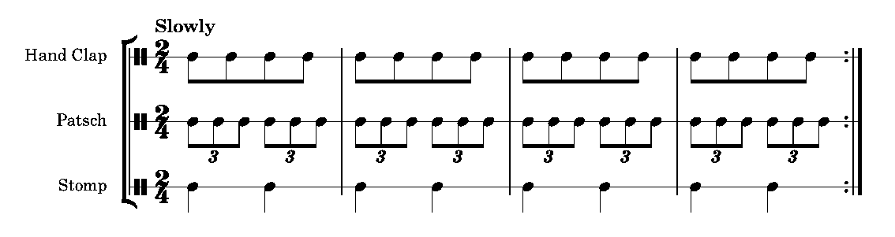
Body, whole class – learning Passion section B olstinati (20 mins)

- Transfer the Starter Activity rhythms onto the Sop. Xylophone and Alto Xylophone parts, Pattern A. The parts can be played on any classroom instruments, but will sound best if octave separation is maintained (i.e. soprano parts sound one octave higher than Alto which sound one octave higher than bass).
- Divide the class up into more parts. In this class, we will learn as many parts for Section B as possible.
- We do this by all learning a part together, following the teacher, and then combining it with all previously learned parts (Orff-Keetman Schulwerk style) so that all students are playing all of the time. We swap students between parts so that they know all parts for all instruments.
- No solo parts are played this week.

Body, small groups – learning same material (15 mins)

- We break out into three groups, to practice the same ostinato and give one another feedback.
- Audio files of each part have been shared on the LMS, so if there is any doubt about any parts, students can listen to it to check/copy.
- If groups think they have perfected the ostinati before the class has finished, they can perform to one another. In this case, each group makes an audio recording of their performance.

Pack away and reflect

- Students pack away instruments and then reflect on the lesson in their portfolios, including their group audio recording if they made one. They answer three questions:
- What did I do today?
- What was good?
- What could I improve?

Self Evaluation: (Completed after the Lesson – what worked, what didn’t, guidelines for future or next lesson.

Appendix 1 – Syllabus Content Reference Numbers
In the above unit of work, Syllabus Content is given a Reference Number to save space. The numbers are allocated in the order that they are published in the Syllabus. Thus:

Performing
 | Music in practice |  | Music in context
1 | Sing demonstrating melodic and/or harmonic awareness | 12 | Apply stylistic characteristics in performance
2 | Develop vocal and/or instrumental skills individually and in groups | 13 | Understand the purpose of a performance
3 | Perform music in a range of musical styles to communicate musical ideas | 14 | Communicate musical ideas with expression
4 | Perform in an ensemble recognising own role and those of others | 15 | Perform with consideration of composer and audience perspectives
5 | Perform own compositions and those of others | 16 | Perform to audiences in different settings
6 | Improvise on a given musical stimulus to develop musical ideas | 17 | Apply the protocols and responsibilities of working safely and respectfully with others
7 | Perform from musical scores | 18 | Make ethical choices about how music is used in performance, including use of Indigenous Cultural and Intellectual Property (ICIP) protocols
8 | Apply knowledge of musical terminology to rehearse and perform | 19 | Demonstrate understanding of risks and protocols related to information and identity
9 | Experiment with technologies to explore creative possibilities
10 | Demonstrate safe vocal and instrumental practices including correct posture, warm-up and technique
11 | Reflect on own experience of performing to develop performance skills

Listening
 | Music in practice |  | Music in context
20 | Listen to live and recorded music and identify musical features and ideas | 29 | Describe music in relation to a particular time period, culture, genre or style
21 | Listen to and explore a range of repertoire to compare pieces of music | 30 | Make connections between pieces of music
22 | Identify and describe the use of technologies in repertoire | 31 | Describe the stylistic, historical or geographical origins of pieces of music
23 | Interpret a range of musical symbols and follow scores that include notations relevant to the repertoire | 32 | Recognise the purpose of a piece of music
24 | Use appropriate musical terminology to describe and discuss music | 33 | Describe how music of Aboriginal and Torres Strait Islander Peoples can communicate Cultural understanding of Place, Country or Languages
25 | Use written, verbal and multimodal forms to describe how musical ideas are communicated | 34 | Discuss music from the perspectives of composer, performer and audience
26 | Use listening skills and memory to clap, sing or play musical patterns | 35 | Reflect on aesthetic qualities of music in personal responses to repertoire
27 | Transcribe musical patterns using notations relevant to the repertoire | 36 | Discuss how identity can be reflected in music
28 | Use listening skills to reflect on own live or recorded performances and compositions | 37 | Describe how music is adapted or arranged
 |  | 38 | Compare versions of a piece of music to explore different responses and interpretations over time
 |  | 39 | Identify cultural and social protocols in relation to repertoire
 |  | 40 | Identify processes to support ethical choices when engaging with Aboriginal and Torres Strait Islander music
 |  | 41 | Describe the influences on a piece of music, using written form and appropriate music terminology

Composing
 | Music in practice |  | Music in context
42 | Improvise and creatively explore musical ideas in response to a stimulus | 48 | Explore how conventions of different styles and media can be used to create meaning
43 | Improvise and experiment to communicate musical ideas | 49 | Create musical ideas reflective of a genre or style
44 | Experiment with different ways of combining musical ideas | 50 | Compose music inspired and influenced by Australian works, including Aboriginal music within appropriate local contexts, while working with local Community Knowledge Holders where possible
45 | Use a range of sound sources, sound production methods, timbres and digital technologies to improvise, generate, compose, manipulate, arrange, notate and record musical ideas | 51 | Research cultural, historical and social influences to inform own compositions
46 | Document musical ideas using notations appropriate to the style | 52 | Compose with a consideration of performer and audience perspectives
47 | Reflect on and document in writing compositional choices and processes | 53 | Adapt pieces of music or their features for new purposes
 |  | 54 | Apply protocols with respect for Aboriginal and Torres Strait Islander musicians, Communities and Cultural Knowledges, as well as Indigenous Cultural and Intellectual Property (ICIP)
 |  | 55 | Apply the protocols and responsibilities of working safely and respectfully with others
 |  | 56 | Demonstrate understanding of risks and protocols related to information, identity and intellectual property when sharing compositions or other material on public or private forums

