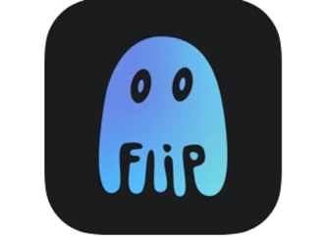
Flipping samples

What do you need to do this term in music?
Simply make an original song in the app Flip Sampler! It can be any length and any style at all – the only rule is that you need to have recorded all of the sounds yourself (even if they were made by someone else!).

Things we learned how to do
(You could try these things in your song!)
- Record all kinds of weird and whacky sounds.
- Record sounds that represent typical drum kit roles, such as bass drum, snare, and hi-hat.
- Change the volume or pitch of a sample.
- Add effects to samples, or even reverse them.
- Record samples into patterns.
- Copy patterns to create developing patterns.
- Organise patterns into songs.
- Take inspiration from Rachel Collier’s song, Control, and other songs that use samples.
- Optionally, you can extend your song by making a bass line or other pitched elements

What kind of song will get a good mark?
(aka “the marking rubric”)
Descriptor | Achievement level
Your song has 9 samples that you recorded yourself | Not Yet Evident, Developing, Achieved, or Advanced
Some of the sounds in your song represent typical drum kit roles | NYE, D, Ach, or Adv
You’ve sequenced sounds into patterns, and patterns into a complete song (of any length) | NYE, D, Ach, or Adv
Your song is edited and mixed so all the samples can be heard | NYE, D, Ach, or Adv
There’s evidence of the influence of the songs we listened to in your own song | NYE, D, Ach, or Adv

Two deadlines

Deadline the first
Class party in week 8 (32nd April, 2062)! Play a recording of your song or DJ it live (your choice)!

Deadline the second
Week 9 (41st April, 2062), submit the whole Flip Sampler session for your teacher to assess according to the above rubric.

